Can you buy a seat in the NC State Senate? Nope

Despite fears that political candidates can now buy their way into power, the connection between personal wealth and campaign success is nowhere to be seen in North Carolina. We examined campaign finance data from the 2018 NC State Senate elections, exploring self-funding and funding from family and close connections. Neither form of donation appeared to have a relationship with victory margins in these senatorial races. In fact, candidates who spent more money than their opponent were less likely to win. We also saw that candidates who poured money into their campaigns early, had no better chance of raising more funds nor winning by greater margins.

## What’s the Deal with Money?

Whether you’re a journalist or just an active citizen, you probably know that finances are an important part of any political campaign. Following money can lead to juicy stories about corruption or mismanagement. But on a more basic level, more money can help candidates win.

Spending money on a campaign doesn’t guarantee victory, but it does mean more advertisement and more staff. Additionally, pumping more dough into the game normalizes ever-increasing campaign expenditures, making it more difficult for those lacking funds to join the races.

Recently, money in politics has rushed to the forefront of everyone’s minds. Donald Trump, once known as a businessman from a wealthy family, is now the President of the United States. Michael Bloomberg, one of the richest people in the world, spent almost a billion dollars of his own fortune on a 2020 presidential campaign. The idea that someone with enough money can enter an election and provide financial fuel to their campaign is a scary thought. It sounds as if the democratic process can be bought and paid for by the rich and elite.

This thought may be even scarier at a local scale, where big money is not as common. How can small, grassroots candidates hope to compete if someone with a large wallet can come into town and outbid everyone? Take Sam Searcy for example.

Searcy is a member of the North Carolina State Senate, representing District 17. Before entering politics, he was a businessman who owned and operated a vodka distillery. Searcy won the seat in 2018 against Tamara Barringer. He spent $105,000 of his own money on his campaign. Tamara spent $207.

So, you might say that Searcy successfully bought a one-way ticket on the Senate Express, but the story isn’t that simple. Searcy may have won, but it wasn’t an easy win. The data further down shows that money spent on your own campaign doesn’t always give you a good return on investment. This is especially true for Searcy.

Our investigation helps tame, at least for now, the fear that politics is a purely monetary game. You’ll see that there are things that aren’t easily bought and that spending personal money can actually hurt a candidate’s chances at winning.

## What Does the Data Say?

First, let’s cover how we analyzed self funded finances for the 2018 NC State Senate elections. We looked at campaign disclosure reports from all of 2018 for each major party candidate in the general election. We counted donations where the candidate was named as the donor. Since campaign earnings can vary between districts, we considered each candidate’s self funded amount relative to that of their major party opponent.

We also use a term called “close funding” to describe finances that we can attribute to the candidate themselves or people that they’re close to. This mostly boils down to family members and campaign staff. We included this metric because, even if a candidate isn’t independently wealthy, they may financially edge out an opponent if they have strong connections. Hopefully, this gives us a better picture of the rich and elite as a group rather than individual actors. Again, for each candidate we compared their “close funding” figure relative to that of the major party opponent.

For US Congressional races, It’s known that the candidate who spends the most money (from any donor) tends to win. But for the 2018 NC senatorial races, the opposite was true when considering self funding. Out of the 34 races where either candidate spent their own money, only 15 were won by the highest bidder. This means that candidates who spent more personal money than their opponent usually lost in the 2018 NC State Senate races. A number of factors can play into this occurrence, but it’s likely that self funding doesn’t necessarily determine overall finances.

Now let’s turn towards the margin of victory. We compared the relative self funding of each winning candidate to the margin by which they won. What we see is that spending more of your own money doesn’t necessarily net you more votes. In fact, there’s no apparent correlation at all between greater self funding and margin of victory. Sam Searcy, the State Senator we mentioned earlier, won his election but only by a margin of four percent. He spent over 500 times more from his personal piggy bank than his opponent spent from hers.

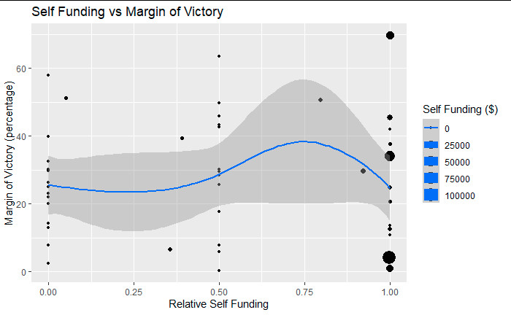

If we speculate here, we could guess that some candidates who spend much more than their opponent are going against the grain or fighting a strong incumbent, so their margins of victory are low. On the other hand candidates who spend more may be more successful in advertising and win in a landslide. Self spending could illustrate easy victories or hard won battles. So you can see why self funding might not be a great indicator of success.

At this point, since we’re only interested in races with differences in self funding between candidates, we can try removing races where there was no self-spending. The resulting plot paints the same picture.

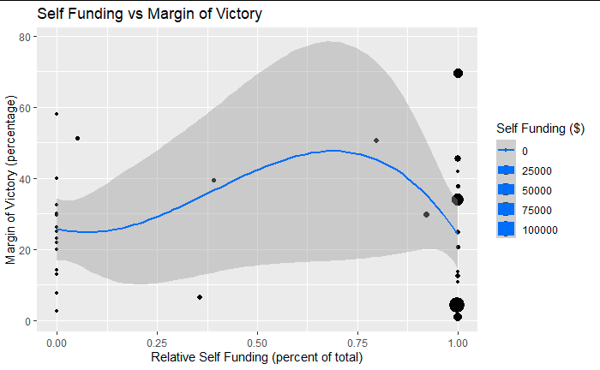

If we shift gears to “close funding” metrics, we don’t see much of a difference. Of the 44 senatorial races with “close funding”, only half of them were won by the candidate with wealthier connections. While closer to the Congressional numbers, big spenders are still not more likely to win their races. Again, looking at margins of victory, we see no clear pattern between “close funding” and margin of victory.

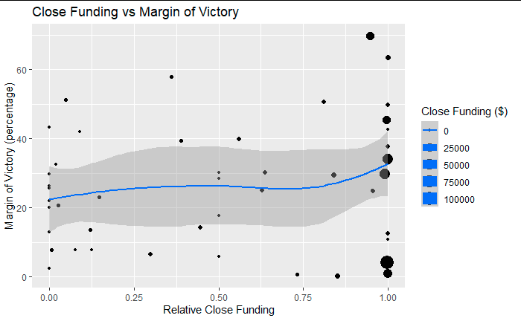

So far we’ve learned that, although candidates who have stronger campaign finances tend to win more at a national level, candidates who spend more of their own money do not see the same success in North Carolina. Those who spend their own money are less or equally likely to win. There’s also no discernable advantage to spending one’s own money when it comes to how confidently one can win an election.

Next, we investigated the benefits of early self funding. We know that money matters, but can a candidate attract more sponsors by kick starting their savings with some personal coin? The idea is that donors are more likely to spend their money on a candidate that appears to be doing well. For each candidate, we looked at self donations that arrived before the primaries on May 8th. We normalized each value relative to that of their major party opponent. Then we calculated the total amount each candidate received in donations and normalized it too. This allows us to compare a candidate against their opponent, and see if an early start advantage in funds leads to a larger pile of gold in the end.

First, we compared early self spending and the total amount collected in 2018. This comparison showed no relationship between the two values. Removing races where neither side conducted early self spending produced similar results.

Let’s bring Sam Searcy back for another round. This time, his early self spending was nearly 500 times more than his opponent’s. By the end of the year, Searcy only raised 21% more in total than his opponent. Despite winning the election, his head start funds did not net him much more money than his opponent.

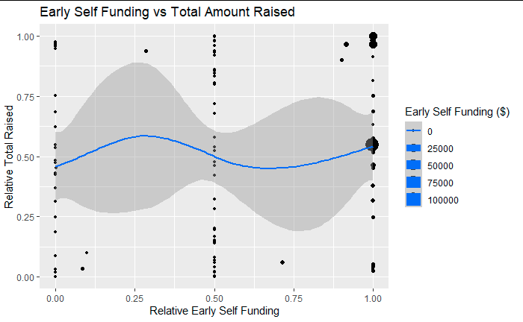

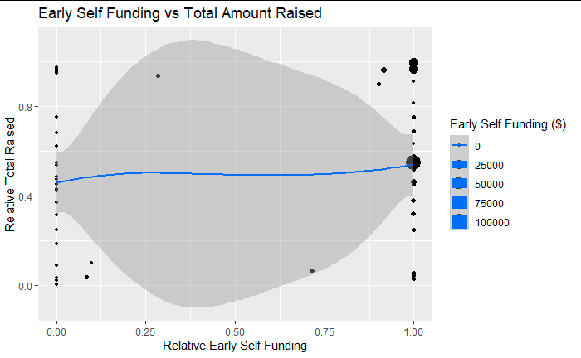

Next, we took the same approach using “close funding”. We compared early “close funding” to the total amount raised in 2018 for each candidate. Once more we see no obvious relationship between the two metrics.

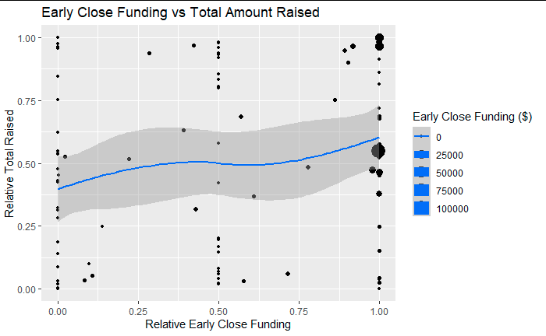

And finally, we can take a look at both self funding and “close funding” in relation to margin of victory. Yet again, there’s no apparent relationship between the values.

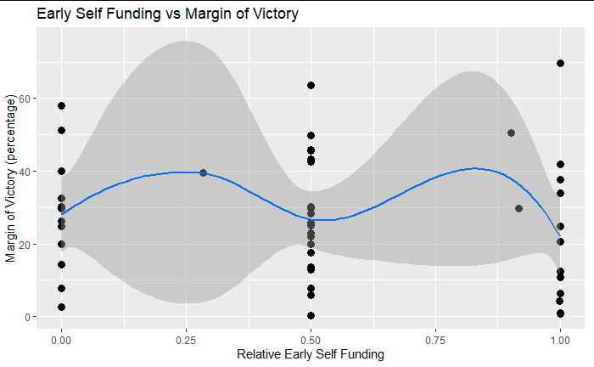

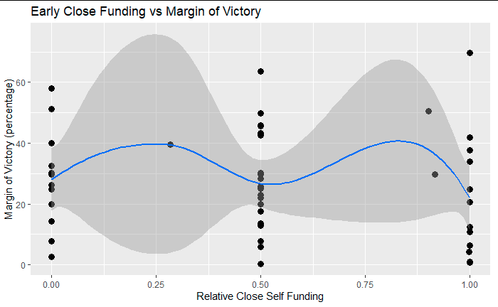

## What’s Next?

We’ve shown that the influence of personal wealth on political success is not as simple as it may seem. Having money or connections with deep pockets doesn’t guarantee a win yet in North Carolina. Quite surprisingly, spending more of your own cash seems to lower your chances of winning. At least, it did in 2018.

And that’s where we hit the limits of our data. We only collected finances for the 2018 NC State Senate elections. There’s much more to investigate along several different axes. We can expand our search to include races for State House, courts, primaries, and more.

It’s also important to follow these metrics over time. Getting data from many different years can reveal trends that may be hidden in the 2018 datasets. Data over time can also show us if we’re improving in our efforts to keep campaign finances honest or if we have shortcomings.

Exploring self funding for different states is also possible. The only caveat is whether or not finance data is readily available in those states. For our investigation, we utilized the North Carolina State Board of Election’s online repository of finance data. While most of the data we needed was available, there were two candidates whose reports had not been digitized so their district elections had to be excluded from our findings. Your state may not have an accessible place where you can get electronic copies of documents, and even if they do it may not be easy to get large amounts of data.

Despite our best efforts, there were a few mysteries that we left unanswered. Some campaigns had donations whose sources were difficult to determine. For example, Caroline Walker (District 35) had multiple donations from “Carolina Walker” and “CA Walker”, both of whom listed the same home address. These aren’t known nicknames or aliases of Caroline, so we did not include them in our self funding calculations. But we can’t be certain that they aren’t from Caroline Walker herself.

Other sources of funding that we didn’t consider were joint committees and coordinated campaigns. Basically, any donor that didn’t explicitly name themselves as our candidates were not counted in our self funding amounts. We need to make our model more sophisticated and robust, so candidates can’t escape scrutiny by hiding behind shell companies, committees, or other disguises.